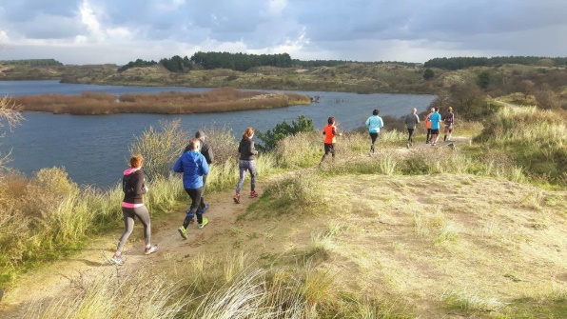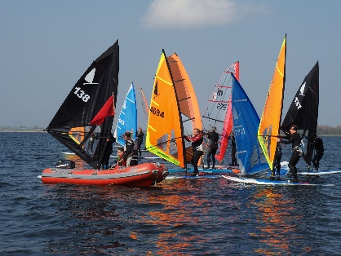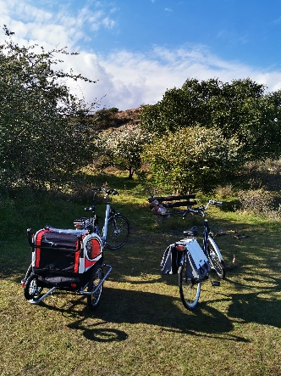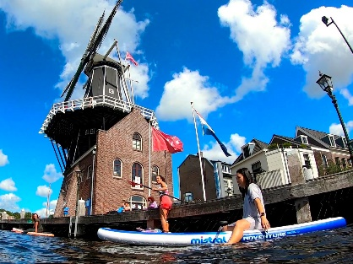



We offer fun tours to active explorers of all levels

|  |  |
| --- | --- |
| **Who we are** Sport and Tours is a company based in Haarlem delivering quality services in outdoor sport activities, Stand Up Paddle (SUP), Windsurf, Biking, Kayak and Hiking. We operate majorly around the area of Haarlem, Amsterdam and surroundings. We provide our customers the equipment and the expertise of professional instructors-and athletes. **Our** **Team** Sport and Tours is managed by the multicultural team; Claudio Duran, Paolo Iodice and Lucien van Delst, who are sharing the strong connection to sports- and outdoor activities, as well as towards nature and water. Claudio is a SUP athlete, who has competed 6 years in different locations worldwide and participated in the 2019 and 2020 edition of SUP 11 SUP City Tour. Since this year, he is Mistral team rider competing in the 2021 European tour and the Dutch national championships. Paolo is an ASI-certified SUP instructor, NLP practitioner and a mental coach. He was a professional windsurfer in the 80s and he is now competing as Master athlete in both disciplines. Lucien is a full dedicated expert windsurfer in classic disciplines and is a CWO-certified trainer, who has competed many Dutch-, European- and World Championships over the last 20 years. Due to our sportive background, we want to inspire our customers with offering them our wide range of outdoor activities and to facilitate them a great experience. | **Our mission** Sport and Tours mission is delivering sportive- and recreational activities for a memorable experience. We want to provide our customers (group of friends, colleagues, family members and so on), an effective way to have fun, to enjoy and or to reduce working stress by injecting them with some fresh- and positive energy. Our aim is to provide you an unforgettable experience.    Our goal  Sport and Tours aims is to deliver high quality services that respond to the customer’s needs and level of experience of the participants. From teaching the basics to beginners to bringing intermediate and advanced to the next level, or just having fun with the group during our tours, our commitment is to deliver our services in a professional, engaging and relaxed manner.    **Our Services** |

## SUP

The fast growing sport of SUP – Stand up paddleboard is an excellent, easily accessible work-out and a fun way to explore the Dutch canals and rivers. We offer SUP tours in Haarlem and Amsterdam, where participants can learn the basics of paddling. We also offer a variety of different workshops and clinics, to sharpen existing skills and bring them to the next level.

Please bring a towel and swimming clothes (swimsuit or surf shorts on warm days, on colder days running clothes are recommended)

|  |  |
| --- | --- |
| **Sup Tour**   * Guided sup adventure in various location in Noord Holland * Haarlem or Amsterdam sup tour on historical canals * Small / medium size groups * All material included   **Sup single lesson and Clinic**   * Practice and improve your sup technique while exploring Haarlem or Amsterdam. * Learn advanced technical drills throughout fun activities * Open to all ages and levels * 2 Hour clinic includes also the material | **Sup Workshops**   * Improve your stability on the board and paddling techniques * Learn how to perform basic manoeuvres by professional sup athletes * For intermediate and experienced paddlers * 1.5 Hour workshop includes also the material   **Sup Rentals only available in Haarlem**   * Rent all the material you need to have fun with your friends. * Top equipment provided by Mistral * Selected fun routings to explore |

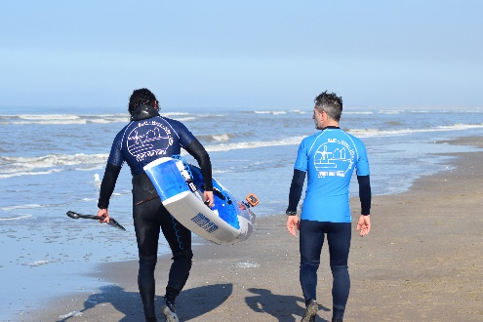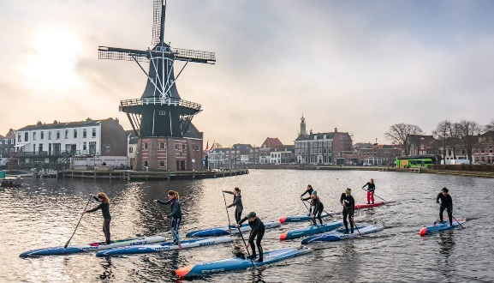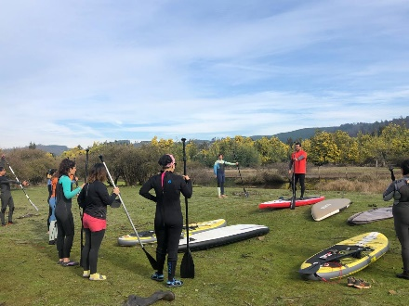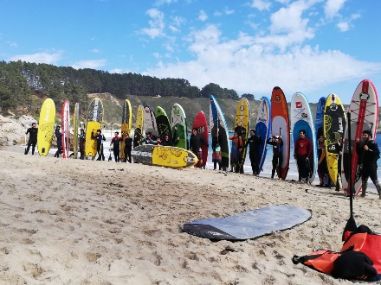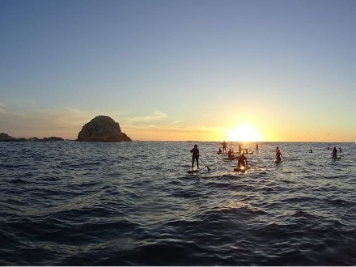

|  |  |
| --- | --- |
| BIKE Bicycle tours  Explore by bike with your teammates a list of selected locations we can propose around Noord Holland  Visit Haarlem and Waarderpolder bike tour  The most significant historic places in town, the beauty of Mooie Nel, and the Waarderpolder the perfect place to make birdwatching.  Visit the Kennemerduinen park bike tour Venture out the unique coastal natural environment of the dunes, packed with an incredible biodiversity KAYAK We offer kayak rentals, single or double totally equipped so that you can enjoy paddling the surroundings of Haarlem. Come and have great time with friends and colleagues and enjoy the perfect combination with SUP. | Hike Only a short drive from Amsterdam's bustling city center, you find true peace and quiet in the National Park Zuid Kennemerland. Our hike will take you through this unique ecosystem where deers, Scottish highlanders, and Shetland ponies are walking freely in the park. The hike takes us on paved bicycle paths as well as dirt trails. Although these trails are well travelled, we will climb some sand dunes. Walking or running shoes are advised. Hiking boots aren't required. |

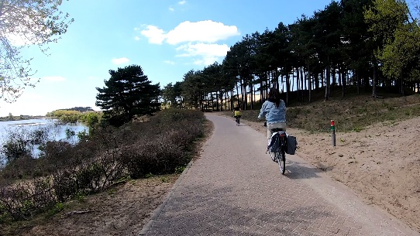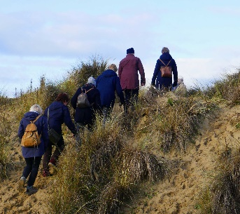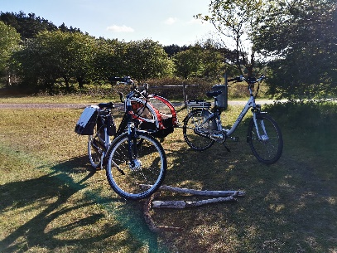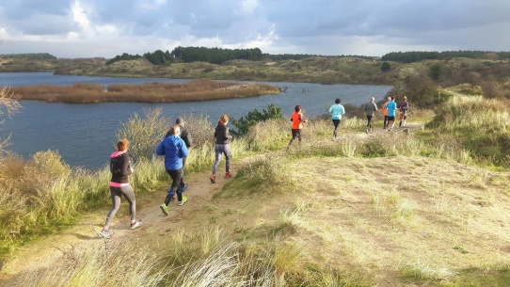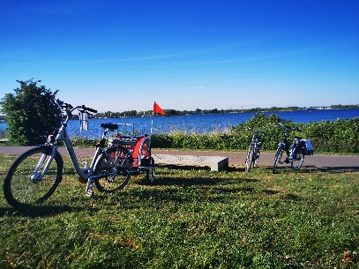

Windsurfing

Windsurfing is back!! In the 1980’s windsurfing was one of the biggest watersport activities in Holland, and now, 40 years later, it’s back!! If you want to challenge your body and mind, windsurfing will be the sport for you!! It´s also a fun way to explore the small lakes and channels surroundings of Haarlem, Amsterdam, and Utrecht. Sport and Tours offers Lessons & Clinics for those who want to learn the basics and Workshops & Tours for the somewhat experienced windsurfers.

Please bring towel, swimming clothes and water shoes. If necessary, wetsuits are available

|  |  |
| --- | --- |
| **Windsurfer Tour**   * Guided Windsurf adventure in Noord Holland, Utrecht and Zuid Holland * Haarlem and Amsterdam surroundings on canals and in national parcs * Groups: 2 / 8 persons * 2 – 4 hours, all material included   **Windsurfer single lesson and Clinic** Practice and improve your Windsurfer skills from basic to the next level while exploring the lakes round Haarlem or Amsterdam.   * Learn advanced technical drills throughout fun activities * Open from 8-> ages and all levels * 3 days 3 Hour clinic, all material included | **Windsurfer Workshops**   * Improve your techniques/tactics to the higher level to control the windsurf board and rig * Learn how to perform the basic manoeuvres by professional windsurf athletes * For intermediate and experienced windsurfers * 1.5 Hour workshop, all material included   **Windsurfer sets Rentals only available in Haarlem**   * Rent all the material you need to have fun with your friends * All equipment provided by Mistral, Windsurfer, Thommen & VANDENBERG and Kona ONE OD * location negotiable |

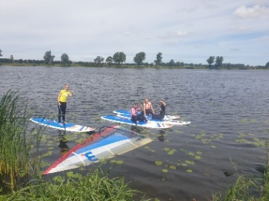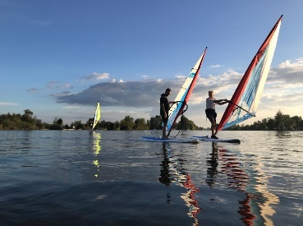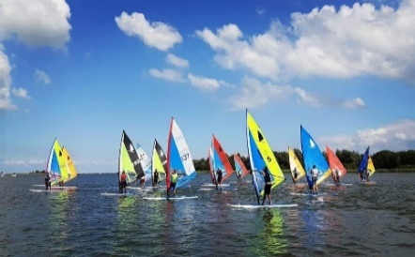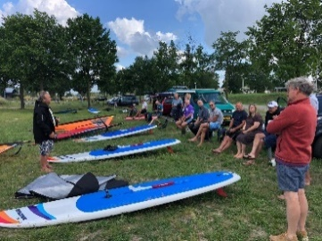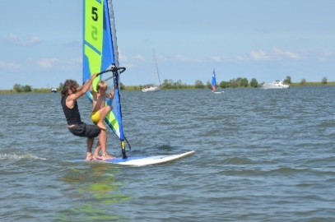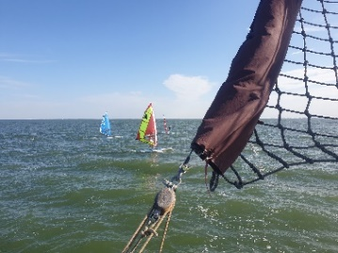



Price

|  |  |  |
| --- | --- | --- |
| **SUP** | **Sport and Tours** | |
| Tour 2h | € 25,00 | |
| Tour 5h | € 100,00 | |
| Single lesson | € 40,00 | |
| € 35,00 | 2-3 persons |
| € 30,00 | 4 persons or more |
| Rentals 2h | € 25,00 | |
| Rentals 5h | € 50,00 | |
| Workshop | € 50,00 | |
|  |  |  |
| **Hike** | **Sport and Tours** | |
| Tour 6h | € 40,00 | |
|  |  |  |
| **Bike** | **Sport and Tours** | |
| Tour 5 h | € 45,00 | |
|  |  |  |
| **Kayak** | **Sport and Tours** | |
| Tour 2 h | € 25,00 | 1-2 persons |
|  |  |  |
| **Windsurfing** | **Sport and Tours** | |
| Windsurf Tour | | |
|  |
|  |
| Windsurf Tour FIRST step.. | | |  |
| Windsurf lesson and Clinic | | |  |
|  |
|  |

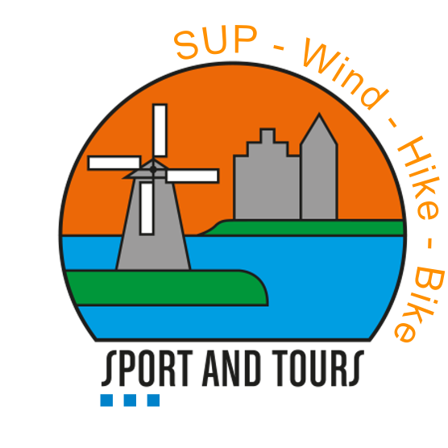

Enjoy a memorable experience!!

sportandtours

WWW.SPORTANDTOURS.NL

contact@sportandtours.com

#SPORTANDTOURS